Pierrefonds Badminton Club
(Pierrefonds Community High School)
Presents

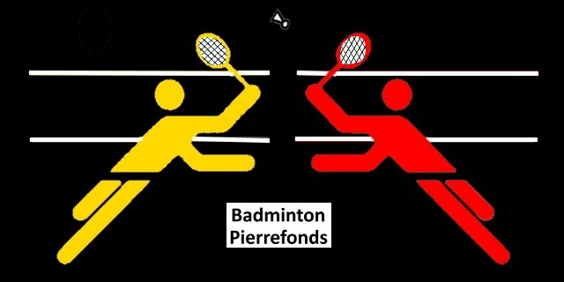

Tournament - Jeux du Québec
Greater Montreal Region
Year – 2023

November 20, 2022
Pierrefonds Community High School
Pierrefonds
General Information
Date : 20 November 2022 - From 9 a.m. to 7 p.m.
Host: Pierrefonds Badminton Club
Address: Pierrefonds Community High School
13800 Pierrefonds Blvd, Pierrefonds, Québec H9A 1A7
Email: badmintonpierrefonds@gmail.com
Cell: 514-978-9169 & 514-562-9558
Contact: Jenny Han & Maggie Song
Facilities : 12 courts
Cloakrooms & Showers
Stringing Machine
Beverages (for sale)
Registration Fee: There will be a cost of $20/athlete for registration, and this includes 2 feather shuttlecocks for matches.
Registration deadline: Registrations must be received by Friday November 11, 2022, BEFORE 6:00 p.m. to the attention of: Jenny/Maggie at badmintonpierrefonds@gmail.com
*IMPORTANT NOTE: Each player, at the time of registration, must bring their school report card with the postal code of their address.
The next step is to ensure that the player lives in the lac-st-louis area. This will be possible with the postal code on the school report card.
You can know which regions are in Lake-Shore : https://www.jeuxduquebec.com/les-regions/

And, for each postal code, in which region that is: : https://fr.wikipedia.org/wiki/Liste_des_codes_postaux_canadiens_d%C3%A9butant_par_H

REGULATIONS
Chief Referee:
A responsible and competent person acts as chief referee on the competition site.
Categories:
Boys and Girls Singles and Doubles (Born in 2006, 2007 and after)
Tournament Style and Type:
Double elimination in singles, except for the final. The top three in each discipline will be selected to go to the Jeux du Québec finals.
Regional selection mode:
The three best in each discipline will be selected to go to the final of the Jeux du Québec.
Bird type:
Feather
Clothing:
A uniform t-shirt and shorts will be an appropriate. T-shirts of substance and/or illicit advertising, with connotation of violence and headgear will not be accepted.
Official rules used:
The regulations of the Fédération Québécoise de badminton will be in effect. The specific rules will take precedence over the official rules.

Registration Form
Please fill the form below and send it to the email address badmintonpierrefonds@gmail.com on or before Friday November 11, 2022, BEFORE 6:00 p.m. to the attention of: Jenny/Maggie.
S.No. | Player Name and Club | Sex (M/F) | Categories |  | Date of Birth | Postal Code | Doubles Partner
 | Last Name, First Name (Club) |  | Singles | Doubles | DD-MM-YYYY |  | Last Name, First Name (Club)

Club Name:
address:
Contact Person:
telephone:
email:
contact person at the tournament:
PAYMENT:
Please make one check based on the number of registrations from the club. The check should be payable to “Pierrefonds Badminton Club”. The check can be handed over to us on the day of the tournament at the registration desk.

